How to Book Tigerair – Clue card

Look for neutral or carrier specific display Availability or fare shopping | A05APRSINDPS  A05APRSINDPS*TR  ZFSSIN05APRDPS
Book required class | N1Y1 from availability  OR  Fare Shopping TAB to Book:>ZFSK01/01  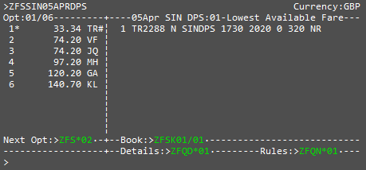  From a Neutral Search  Seat Sell N1Y8  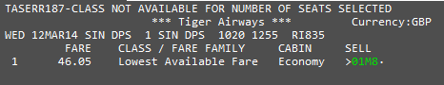 | From Smartpoint neutral availability clicking on the class will do a direct sell  To select a different itinerary option from fare shopping TAB to >ZFS*02  to move to option 2 then TAB to Book:>ZFSK02/01  A12MARSINDPS  This will display the available class to sell, M class  Typing the format or clicking on this will then book the available class
Enter mandatory passenger information | N.TEST/LORNA MISS  T.T*  W.10 HURRICANE WAY*SLOUGH*BERKS*GB*P/SL3 8AG  MT. or MF.  P.  SI.P1/SSRDOCSTRHK1////GB/12JUL76/F//TEST/LORNA  R. | Surname, First Name and Title are Mandatory  5 Fields required for the address including country GB and post code *P/  Date of birth and Nationality are required to end booking (Use Current GDS Formats for SSRDOCS)
Fare Quote Booking | FQ  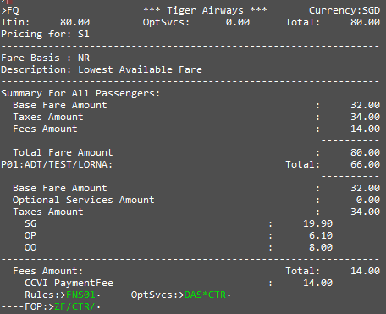 | If you have scheduled carriers you will need to quote individually i.e. FQSx (x= Segment number)
Selling ancillaries | TAB to DAS*Cxx (xx=API Connected carrier)
To sell a bag/Xtra Weight/ Bundled Services/ Meals/ Sports Equipment or Priority Boarding  To Display Seat Map and book Seats | Make sure “*” is next to the service required :  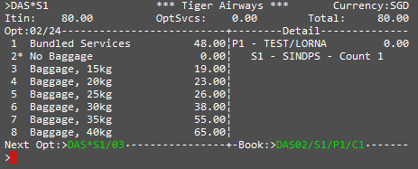  Then TAB to Book: >DAS01/S1/P1/C1  Count added to the detail screen:  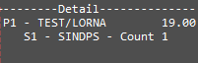  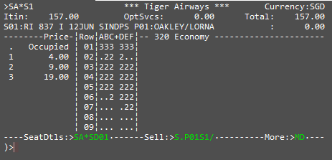  TAB to Sell:>S.P01S1/  Indicate from the seat map which seat is required, and enter it after the “/” or tab stop and hit “Enter”  Response on the details screen:  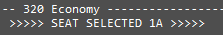 | C1 = to number of bags required, Count 1  Please note the number in the seat map represents a price i.e. 1A costs SGD19.00  The prices are detailed in the legend on the left hand side.  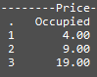
To display a Summary of the booking | DAS*SUM  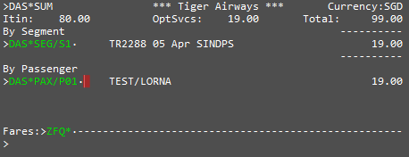 | You can also drill down further by pax to look at their specific Optional services booked.  DAS*PAX/P01
To Pay for and complete booking  Tigerair Carrier’s currently available to book via TAS  ZPROV Functionality to add a User ID and Password for Agency Payment  Tigerair Support the following currency’s | Enter ZF* and credit card information in the Book:>ZF/CTR/CC/ after the “/” or the tab stop then hit “Enter  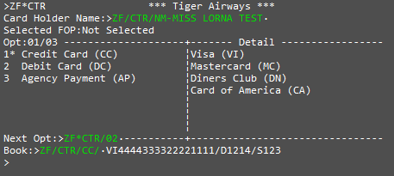  Or  With name added to the payment (This is not mandatory and required only if Name on CC does not match Travelers name.  ZF/CTR/CC/.VI4444333322221111/D1215/S123/NM-MISS LORNA TRAVEL  Agency Payment can also be used as per option 3  ZF/CTR/AP/X1234  (Agency payment with Agent Payment ID only for carrier Tigerair)  Or  ZF/AP/X1234/PASSWTP  (Agency payment with Agent Payment ID and Password details for all segments in the PNR)  (If the Password has Lower and Upper case Characters, please see below entry format)  ZF/AP/X1234/PASS*w*o*r*d  (must enter a “*” before each lower case character)  Response received:  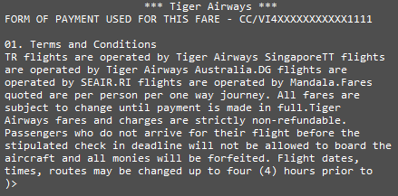  Now enter “ER”  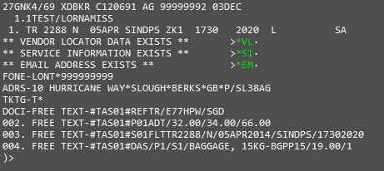  Tigerair Singapore (TR)  Tigerair Philippines (DG)  Tigerair Mandala (RI  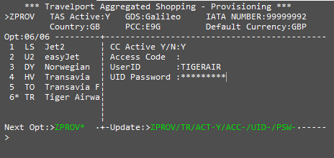  Enter in the Agency ID against (User ID) and UID Password for Agency Payment option  ZPROV/TR/UID-TIGERIAR/PSW-NEWSKIES-1  AUD  CNY  EUR  GBP  HKD  IDR  LKR  MYR  NZD  PHP  SGD  THB  TWD  USD | Please note credit card information will come across from the FOP line if present. You can override by typing new credit card details.  For agency payment field please contact Tigerair to obtain an account for the airline.  Upper and Lower Case Entry for Passwords (Lower case cannot be entered into the GDS)  Please see entry in Left column to identify how to work with Upper and Lower case.  Galileo Reference returned and Easyjet vendor locator under *VL.  To display the booking in the Tigerair system enter Z*R/CTR  Please note Modify and Cancel is not available as yet  Please note only a Secondary user can update this display  Please use the Update Tab below to enter the Agency ID and UID Password for the agency

